
CSI3105: Software Testing
Workshop 5: Control Flow Testing
Submission Date: None
Tasks from this workshop must be completed. These tasks will contribute to your ability to complete the Assessments.
Related to Learning Outcomes:
- Apply different test case design techniques, recognising the strength and weakness of each and being able to choose techniques appropriately.
- To develop test cases using control flow
- To demonstrate an understanding of test adequacy associated with control flow

This workshop covers:
- White box test case generation techniques and test adequacy

Task A Control Flow Graphs
- Draw the control flow graph for the segment below:
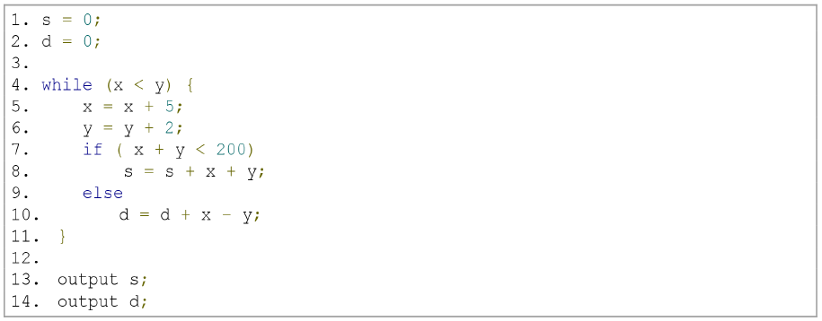
- Draw the control flow graph for the segment below:
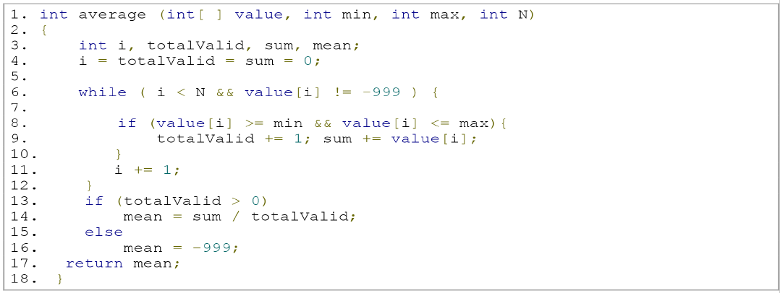

Task B Test Coverage
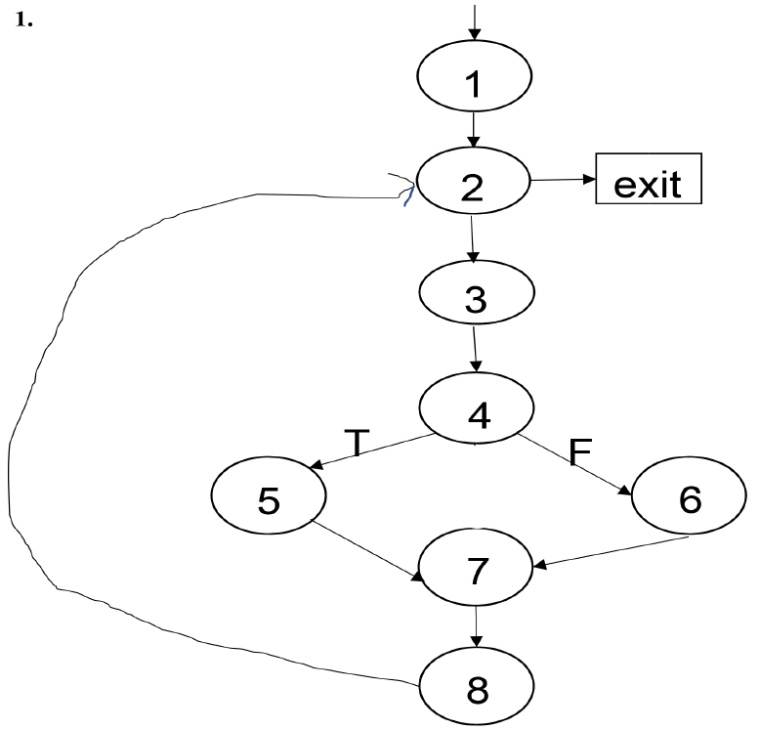
Given the CFG above, two test paths were generated. These are:
1 – 2 – exit
1 – 2 – 3 – 4 – 5 – 7 – 8 – 2 – 3 – 4 – 5 – 7 – 8 – 2 – exit

- Has 100% statement coverage been achieved with these two paths? Provide rationale for your answer.
- Has 100% branch coverage been achieved with these two paths? Provide rationale for your answer.
- Provide additional test paths where needed to achieve 100% coverage.

Task C Basis Paths
- Using the CFG from Task A.2, calculate the cyclomatic complexity
- Using the CFG from Task A.2, find the basis path set
- Derive your test cases for question 2.

